Text for the Website

-All text to be put on the website are in bold.

1. Frame 1: talkativechef.com
2. Frame 2:
   1. Logo
   2. Search button has a watermarked search magnifying glass:  and the words: **What would you like to make?**
   3. Below search bar, faded into the background **New to Talkative Chef?**
   4. Search Results
      1. On Side of the Search Result Area: Filters (optional)
         1. Meal
            1. Breakfast
            2. Brunch
            3. Snack
            4. Lunch
            5. Appetizer
            6. Dinner
            7. Dessert
      2. On top of the search result area: **Sort**
      3. Next line. From left to right of Screen:
         1. **Relevance**
         2. **Rating** (This one has a drop down box that says the following):
            1. **High to Low**
            2. **Low to High**
         3. **Time** (This one has a drop down box that says the following):
            1. **Less Time to More Time**
            2. **More Time to Less Time**
      4. Search results will be tiled below search bar after user clicks enter for the query. Search Results will be tiled on a white, or at least nice lighter colored background that users can scroll down to (if you had a different idea for this, let me know).
         1. One tile will look like this:
            1. First, the name of the dish like: **Best Chocolate Chip Cookies**
            2. Line after: Star Rating: , Time: Picture of a clock and the time written afterwards. Something like this: ** 45 min**
            3. Line After: Nice clear picture of the finished food
3. Frame 3: Scratched – now part of Frame 2
   1. After user picks a recipe on Frame 2, they reach Frame 3, which is the actual recipe.
4. Frame 4:
   * 1. At top of the page, recipe title such as: **Best Chocolate Chip Cookies**
     2. Next Line.
        1. **Yield: Feeds 24 People  45 min**
        2. Next Line:
           1. Left Column:

**Ingredients**

**- 1 cup butter**

**- 1 cup white sugar**

**- 1 cup brown sugar**

**- 2 eggs**

**-3 cups flour**

**…**

(However the ingredients appear on the API recipe page we are using)

* + - * 1. Right Column:

Beautiful picture of the finished food from the tile thumbnail, but enlarged.

* + - 1. Next line:
         1. Start Button: 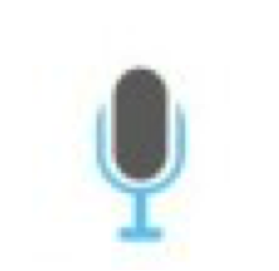Maybe also “**Press to Start Directions**”
         2. **Directions:**

**Preheat oven to 350 degrees F (175 degrees C).**

**Cream together the butter, white sugar, and brown sugar until smooth. Beat in the eggs one at a time, then stir in the vanilla. Dissolve baking soda in hot water. Add to batter along with salt. Stir in flour, chocolate chips, and nuts. Drop by large spoonfuls onto ungreased pans.**

* + - * 1. Before the last line of directions, Talkative Chef says, “Last step! Leave a rating!” Last line of recipe:

**Bake for about 10 minutes in the preheated oven, or until edges are nicely browned.**

* + - * 1. Two lines down:

Stop button: 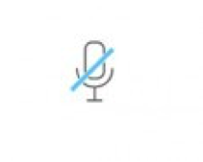Maybe also: “**Press to Stop Directions”**

* + - * 1. Two lines down:

**Please leave a rating for this recipe!**



* + - * 1. The Voice API will record how long it takes for the user to press the stop button. This number will be rounded and averaged across users and used to mark the amount of time this recipe takes to make under “Time.”